**Visual Design Log**

In the case my color schemes and were not defined in my supplementary write-up:

* My color scheme was largely based on black and modern colors.
* Some of the main colors I utilized can be seen in this color palate I created:



These colors are either analogous (the white, grey, and black) or primary (red/blue)

* These colors give my website a minimalistic look, because my research proved that the more expensive websites often have simplistic themes.
* I also designed a logo that shows some vital contact information, as well as links back to the homepage to improve my usability.

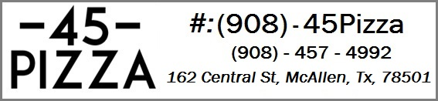

* Stating my address at the top of every page will help enforce to my customers where I am, an ho they are able to contact me
* All in all, I feel my Visual Design accurately represents my website, and will positively impact my customers.